NASPE, Eugene H. Rooney, Jr. Award
Innovative State Human Resources Management Program

Alabama’s Span of Control Guide

Darby Forrester, Classification and Pay Manager
State of Alabama Personnel Director
64 North Union Street, Montgomery Alabama
334-353-4076 (P) 334-242-3636 (Fax) Darby.Forrester@personnel.alabma.gov

In 2014, the Chair of the Alabama Senate General Fund Committee (“Chair”) became increasingly concerned with budget requests from agencies that appeared to be “top heavy” with managerial and supervisory personnel. The Chair justifiably questioned whether the positions were actually necessary or whether it was simply an attempt to provide employees with pay raises as merit based pay raises had been frozen over the previous five years, leaving the only avenue available to Agency Directors for pay increases was through promotions and its’ accompanying promotional raises. Agency Directors defended the promotions as necessary to carry on the day-to-day operations of the agencies, however, the Chair tasked the State Personnel Director to determine the appropriate number of managerial/supervisory positions for agencies. This was “much easier said than done” as span of control does not lend itself to a finite number such as 1:7 (1 supervisor to 7 subordinates or 1:13 (1 Supervisor to 13 subordinates) as there are many different factors which come into play when determining the number of reporting personnel besides an actual number of employees.
A position that supervises a data entry group can supervise more employees as the work is the same for all the positions supervised and the performance factors are easy to identify and measure. A position that supervises professional, technical, and clerical employees has different tasks for positions which requires different measurements between not only classifications, but positions within the classifications. Knowing that a ratio would not take into account all facets of span of control, the Alabama State Personnel Department partnered with Kenning Consulting to develop a guide to provide criteria against which spans of control can be assessed and to provide the Alabama State Personnel Department and decision makers in both the Legislative and Executive branches, as well as agency human resources personnel, a resource by which it can assess spans of control now and in the future.

Brief Description of Program: The Span of Control Guide (the Guide) identifies 13 factors in which judgement is utilized to make span of control decisions. Within the 13 factors are three levels (minimal, moderate, and significant) to determine the impact of each factor within the organization. Also considered in the 13 factors is the concept of core business and enabling support. Core business is solely why the agency exists. There are two types of core businesses in State Government – core agencies such as Corrections and core functions within that agency such as correctional facilities. Enabling support are functions that support the core business. There are two types of enabling support in State Government – statewide core functions such as Retirement Systems, State Employees Insurance, and enabling support within an agency such as the Personnel Division within Corrections that hires Correctional Officers. The core business and enabling support are defined within the three levels which further assists in identifying the impact of the factors. Each level is assigned a point value from 1 (minimal) to 3 (significant). Each factor is rated and receives a score. Once all factors have been rated, the sum of the scores determines the correct number of direct reports necessary to achieve a balance between managers/supervisors and subordinates. The Guide specifically allows a range of direct reports for each level so even within the levels there is not a finite number of reports. For each factor there are definitions for each level, as well as examples, to assist users in determining the correct level. Below are two of the factors considered within the Guide along with the scoring application:

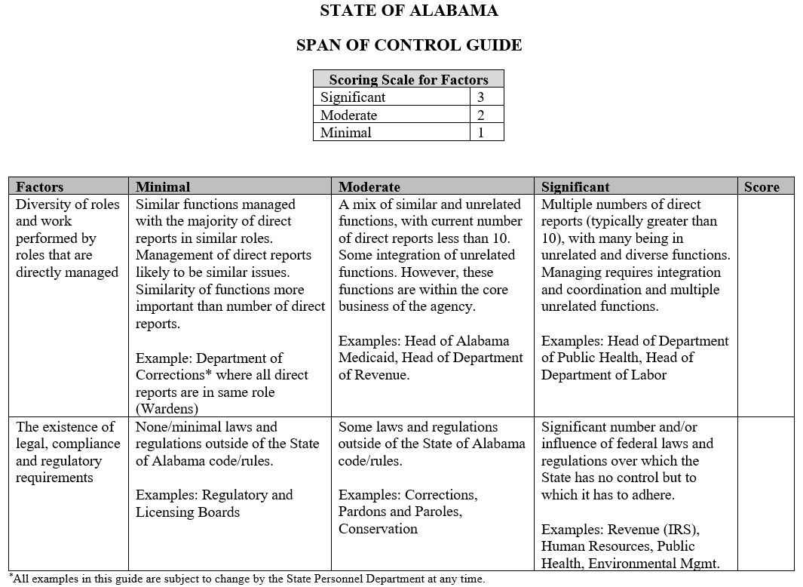
For example, if the position under review was the Director of Facility Management for the Department of Corrections, the position would receive a score of one for the diveristy of roles and work performed. This position is over all prisions which are headed by positions in the Warden classification series. While different levels of Wardens are over different size/security prisons, the work is overall the same – management of the correctional facilities for the Department of Corrections. For the factor concerning legal, compliance, and regulatory requirements, the position would receive a score of two as there are federal and state laws in governing the management of prisons.

Once all factors have been rated, then the sum of the factors shows the optimum number of direct reports for the position under review.
How long has this program been operational: In November and December 2015, the Alabama State Personnel Department and Kenning Consulting piloted this program with three state agencies – Revenue, Public Health, and Corrections. These agencies had been chosen prior to implementation of the project as agencies State Personnel viewed as having the best to least efficient/effective organizational structures and were top-heavy at the highest management levels. Agency directors were interviewed, organizational charts were analyzed, and the 13 factors were scored for each agency. The scores confirmed what the Alabama State Personnel Department had originally determined as the order of best to least effective. The Guide was put into place in January 2016 and has been used continuously since that time. In early 2016, a new Public Health Officer was appointed and used the Guide to re-organize the department, going from 12 direct reports down to 7. Brent Hatcher, Personnel Director for Public Health stated; “The Span of Control Guidelines has allowed our department to equalize duties, allow better communications between supervisors and subordinates and improve budgets. The State Health Officer is committed to using The Guide as part of his continuous Quality Improvement Initiative.”
Why was this program created: It was created at the request of the Chair of the Alabama Senate
General Fund Committee to provide a consistent, reliable measurement tool to be used to determine an appropriate number of managerial/supervisory positions among the state agencies.
Why is this program a new and creative method: The factors and levels contained within the Guide provide 13 factors and three levels to determine a span of control that is based on judgement within an organization that provides for consistency among allocations that may be very dissimilar.
What was the program’s start- up costs: The only cost was the initial development of the Guide which was developed in conjunction with Kenning Consulting.
What is the program’s operational costs: There are no operational costs. The Guide is available for use by the Alabama State Personnel Department as well as individual agencies and the Alabama Legislature.
How is this program funded: There are no on-going costs related to this program. The only cost was the initial development of the Guide.
Did this program originate in your state: Yes.
Are you aware of similar programs in other states: We are not aware of any other similar programs.
How do you measure success of this program: Success will ultimately be measured in salary cost savings as agencies use the Guide to re-organize and stream-line functions and programs. The biggest success, however, is in the equalization of duties between positions in the same classifications and better communication between supervisors and subordinates; not to mention the acceptance of this process by the Alabama Legislature.
How has the program grown and/or changed since its inception: The Span of Control Guide was initially developed for the highest level of managerial/supervisory positions. Now, however, the Guide is used at all levels of managerial/supervisory positions from a first level supervisor all the way through division directors. It is a tool that can adapt to any size agency and with the concept of core business and enabling support built in, it can be used for organizational design and role definition clarity.

